Hill climbing is a simple optimization algorithm used in Artificial Intelligence (AI) to find the best possible solution for a given problem. It belongs to the family of local search algorithms and is often used in optimization problems where the goal is to find the best solution from a set of possible solutions.
- In Hill Climbing, the algorithm starts with an initial solution and then iteratively makes small changes to it in order to improve the solution. These changes are based on a heuristic function that evaluates the quality of the solution. The algorithm continues to make these small changes until it reaches a local maximum, meaning that no further improvement can be made with the current set of moves.
- There are several variations of Hill Climbing, including steepest ascent Hill Climbing, first-choice Hill Climbing, and simulated annealing. In steepest ascent Hill Climbing, the algorithm evaluates all the possible moves from the current solution and selects the one that leads to the best improvement. In first-choice Hill Climbing, the algorithm randomly selects a move and accepts it if it leads to an improvement, regardless of whether it is the best move. Simulated annealing is a probabilistic variation of Hill Climbing that allows the algorithm to occasionally accept worse moves in order to avoid getting stuck in local maxima.
Hill Climbing can be useful in a variety of optimization problems, such as scheduling, route planning, and resource allocation. However, it has some limitations, such as the tendency to get stuck in local maxima and the lack of diversity in the search space. Therefore, it is often combined with other optimization techniques, such as genetic algorithms or simulated annealing, to overcome these limitations and improve the search results.

Advantages of Hill Climbing algorithm:
- Hill Climbing is a simple and intuitive algorithm that is easy to understand and implement.
- It can be used in a wide variety of optimization problems, including those with a large search space and complex constraints.
- Hill Climbing is often very efficient in finding local optima, making it a good choice for problems where a good solution is needed quickly.
- The algorithm can be easily modified and extended to include additional heuristics or constraints.

Disadvantages of Hill Climbing algorithm:
- Hill Climbing can get stuck in local optima, meaning that it may not find the global optimum of the problem.
- The algorithm is sensitive to the choice of initial solution, and a poor initial solution may result in a poor final solution.
- Hill Climbing does not explore the search space very thoroughly, which can limit its ability to find better solutions.
- It may be less effective than other optimization algorithms, such as genetic algorithms or simulated annealing, for certain types of problems.

Features of Hill Climbing

1. Variant of generating and test algorithm:
It is a variant of generating and testing algorithms. The generate and test algorithm is as follows :
- Generate possible solutions.
- Test to see if this is the expected solution.
- If the solution has been found quit else go to step 1.
Hence we call Hill climbing a variant of generating and test algorithm as it takes the feedback from the test procedure. Then this feedback is utilized by the generator in deciding the next move in the search space.

2. Uses the Greedy approach:
At any point in state space, the search moves in that direction only which optimizes the cost of function with the hope of finding the optimal solution at the end.

State Space diagram for Hill Climbing
The state-space diagram is a graphical representation of the set of states our search algorithm can reach vs the value of our objective function(the function which we wish to maximize).
- X-axis: denotes the state space ie states or configuration our algorithm may reach.
- Y-axis: denotes the values of objective function corresponding to a particular state.
The best solution will be a state space where the objective function has a maximum value(global maximum).
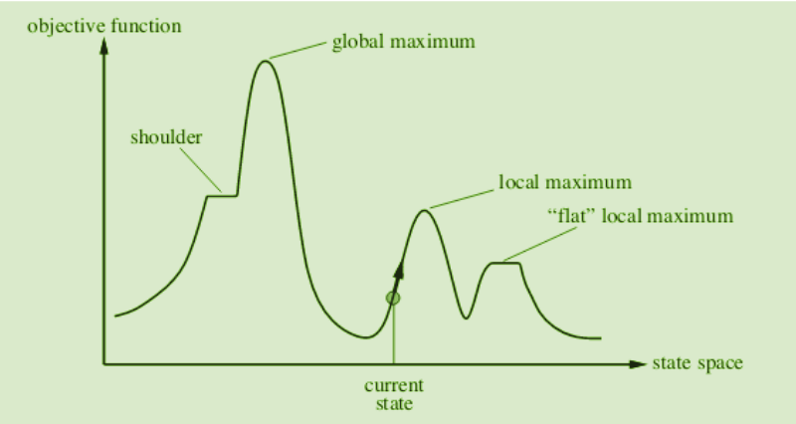

Different regions in the State Space Diagram:
- Local maximum: It is a state which is better than its neighboring state however there exists a state which is better than it(global maximum). This state is better because here the value of the objective function is higher than its neighbors.
- Global maximum: It is the best possible state in the state space diagram. This is because, at this stage, the objective function has the highest value.
- Plateau/flat local maximum: It is a flat region of state space where neighboring states have the same value.
- Ridge: It is a region that is higher than its neighbors but itself has a slope. It is a special kind of local maximum.
- Current state: The region of the state space diagram where we are currently present during the search.
- Shoulder: It is a plateau that has an uphill edge.

Problems in different regions in Hill climbing
Hill climbing cannot reach the optimal/best state(global maximum) if it enters any of the following regions :
- Local maximum: At a local maximum all neighboring states have a value that is worse than the current state. Since hill-climbing uses a greedy approach, it will not move to the worse state and terminate itself. The process will end even though a better solution may exist.
To overcome the local maximum problem: Utilize the backtracking technique. Maintain a list of visited states. If the search reaches an undesirable state, it can backtrack to the previous configuration and explore a new path.
- Plateau: On the plateau, all neighbors have the same value. Hence, it is not possible to select the best direction.
To overcome plateaus: Make a big jump. Randomly select a state far away from the current state. Chances are that we will land in a non-plateau region.
- Ridge: Any point on a ridge can look like a peak because movement in all possible directions is downward. Hence the algorithm stops when it reaches this state.
To overcome Ridge: In this kind of obstacle, use two or more rules before testing. It implies moving in several directions at once.

